Hades enemies details
MELEE ENEMIES
These create close-range pressure and force constant movement.
1A. Small Melee (Swarm Type)
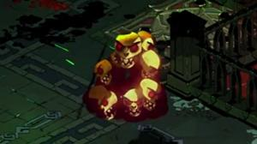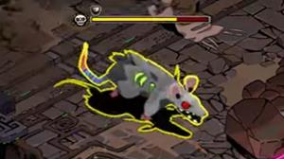
Visual Identity
- Small, aggressive creature
- Sharp limbs or claws
- Quick twitch animations
- Slight glow in eyes
- Low armor appearance
Role in Combat
- Surround player
- Force dodging
- Create chaos
Characteristics
- HP: Low
- Damage: Low (6–10)
- Speed: Medium
- Attack Cooldown: 1–2 sec
- No armor
Behavior
- Direct chase
- Quick strike
- No retreat
Purpose: They are annoying, not deadly alone — dangerous in groups.
1B. Giant Melee (Brute Type)
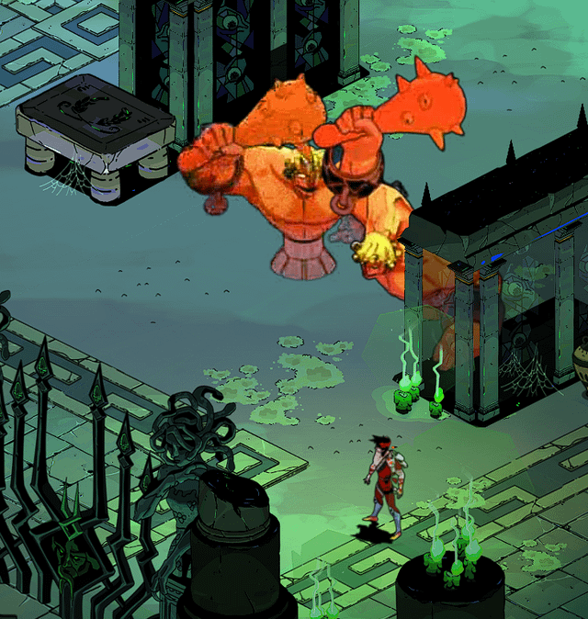
Visual Identity
- Large body
- Thick armor plates
- Heavy weapon (club, hammer)
- Slow walking animation
- Strong attack telegraph
Role in Combat
- Area denial
- Punishes bad timing
Characteristics
- HP: Very High
- Damage: High (12–20)
- Speed: Slow
- Windup: 2–3 sec
- Cooldown: 4–6 sec
Attack Style
- Ground slam (small AoE)
- Heavy forward swing
Purpose: Player must read telegraph and dash correctly.
FAST ENEMIES
These punish poor positioning.
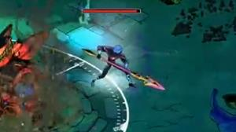
2A. Light Fast (Flanker):
Visual Identity
- Lean body
- Light armor
- Spear or blade
- Quick dash animation
Role
- Hit-and-run
- Attacks from angles
Characteristics
- HP: Low-Medium
- Damage: 8–12
- Speed: High
- Quick dash ability
Behavior
- Circle player
- Dash in
- Strike
- Slight retreat
Purpose: Forces awareness of surroundings.
2B. Armored Fast (Advanced Flanker):
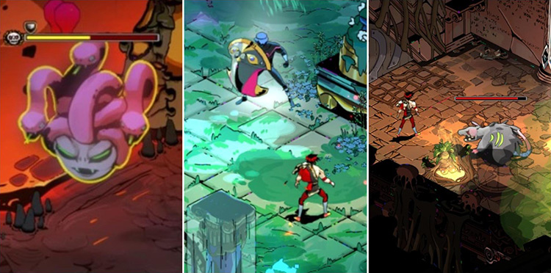
Visual Identity
- Medium armor plating
- Energy shield glow
- Aggressive stance
Role
- Disrupt player rhythm
Characteristics
- HP: Medium
- Damage: 10–14
- Speed: High
- Armor shield (absorbs damage first)
Ability
- Multi-hit combo
- Short invulnerable dash
Purpose: Forces target prioritization.
HEAVY ENEMIES
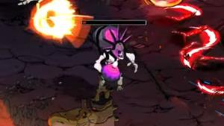
Control space and limit movement.
3A. Standard Heavy
Visual Identity
- Thick armored body
- Large hammer
- Slow animation
- Glowing attack windup
Role
- Area control
Characteristics
- HP: High
- Damage: 14–18
- Speed: Slow
- AoE slam
Purpose: Limits safe zones.

🔹 3B. Armored Heavy (Advanced)
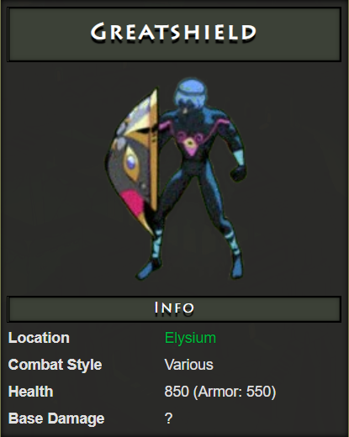
Visual Identity
- Larger armor
- Strong glow accents
- Intimidating posture
Role
- High battlefield presence
Characteristics
- HP: Very High
- Damage: 18–22
- Strong armor layer
- Large shockwave AoE
Purpose: Creates high pressure rooms.

ELITE VARIANT (Modifier)
Elite enemies look:
- Larger
- Glowing aura
- Unique color tint
- Extra visual effect
Stat Modifiers
- +40% HP
- +20% Damage
- Unique ability (rage / shockwave / speed burst)
Summon Rule (Balanced)
Each elite enemy may summon once per encounter.
Total elite summons across the entire run must not exceed 3.
MINI BOSS
Visual:
- Unique silhouette
- Unique weapon
- Dramatic animation
Characteristics
- HP: 4–6× baseline
- 2–3 abilities
- 1 summon at 50% HP
Summon:
- 2–4 small melee

FINAL BOSS
Visual:
- Largest model
- Multi-phase transformation
- Strong visual telegraph
Phase Structure
Phase 1: Controlled combat
Phase 2: Faster, more aggressive
Summon:
- Once per phase

Questions: What can be the player characteristics like closer shot with sword, longer projectile shot? We can define starting parameters these number of close or projectile shots required to destroy this kind of enemy? Once’s done we can generate prompts. We can fine tune the parameters later on. I believe without defining by ourselves, Cursor AI can assume some of them itself and might be difficult to debug?

